RAPTOR Page UI Tech Guide

Last updated 20140222

Contents

Overview 2

Worklist Page 2

Protocol Page 2

Protocol Page Tabs 3

Page Structure 4

Common Top Area Content 5

Dashboard Area 5

Protocol Tab Content Details 7

Important Message Area 7

Static Information Area 7

Data Entry Area 1 8

Sections of the Data Entry Area 8

Data Entry Area 2 9

Sections of the Data Entry Area 9

Acknowledgement Area 10

State Changing Button Area 11

RAPTOR Data Entry Principles 12

Revision History 14

# Overview

RAPTOR navigates directly to the Protocol Page when a user selects a procedure from the Worklist page.

# Worklist Page

The worklist page has the logical sections shown in Figure 1.

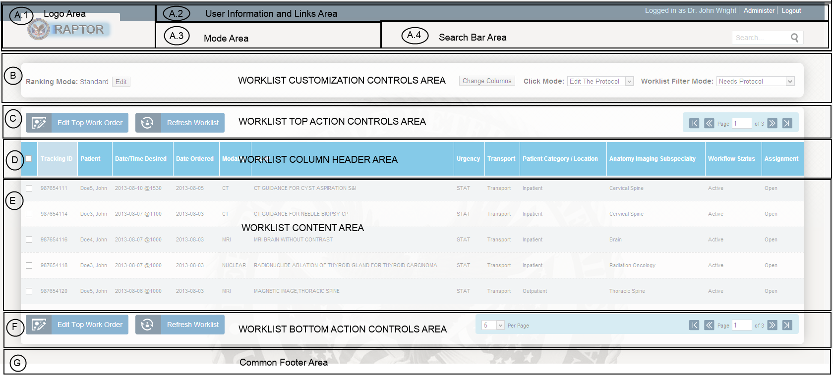

Figure - Worklist Page Wireframe

# Protocol Page

The protocol page has the logical sections shown in Figure 2. The A* section at the top of the page contains the same content as is found in the Worklist page. Also, the Common Footer Area has identical content to what is found in the Worklist page.

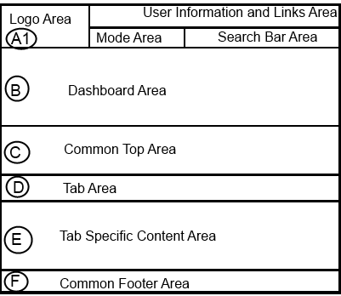

Figure - Protocol Page Wireframe

The internal wireframe of ***Tab Specific Content*** area shown in the wireframe above varies depending on the tab that is selected.

## Protocol Page Tabs

The Protocol Page has multiple tabs, each of which is shown in Table 1.

Table - Tabs of the Protocol Page

| Order | Tab Name | Description |
| --- | --- | --- |
| 1 | Protocol | This is the default selected tab when a user lands on the Protocol Page. This tab area is where all the protocol settings are captured and some read-only background information is made available to help with the protocol process. This is also the tab area where a technician enters notes during the procedure. |
| 2 | Medications |  |
| 3 | Vitals |  |
| 4 | Allergies |  |
| 5 | Labs |  |
| 6 | Dose Hx |  |
| 7 | Clinical Reports |  |
| 8 | Problems List |  |
| 9 | Notes |  |
| 10 | Radiology Reports |  |
| 11 | Protocol Library | This is where we find a listing of all the existing protocols available at the hospital center |

## Page Structure

The content structure of the Protocol Page is illustrated in Figure 3. The **Common Top Area** and **Common Footer Area** contain the same content across all tabs (logo, links, mode, search bar). The **Tab Area** changes visually to indicate which tab is currently selected. The **Tab Specific Content Area** varies depending on the tab which has been selected.

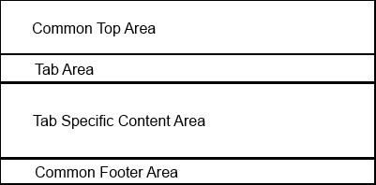

Figure - Protocol Page Content Areas

The structure of the ***Tab Specific Content Area*** of the Protocol Tab within the Protocol Page is illustrated in Figure 4. The structure of this area is different for each of the items listed in TABLE.

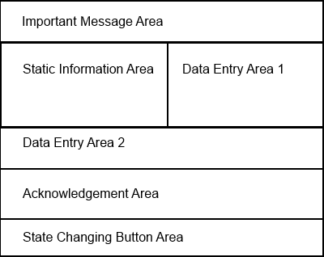

Figure – Tab Specific Content for Protocol Tab (Named Areas)

# Common Top Area Content

The Common Top Area of the Protocol Page has the areas show in Figure 5. The items above the **Dashboard Area** portion of the structure are the same as those seen in the Worklist page.

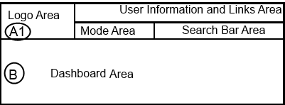

Figure - Common Top Area Structure

The **Mode Area** indicates if the user is in an **Edit** mode or a **View** mode on the Protocol Page. The Search Bar Area provides some enhanced search features to the user.

## Dashboard Area

The Dashboard Area content is a presentation of key information specific to the selected procedure. The Dashboard Area shall display all the information described in Table 2.

Table - Dashboard Content

| Order | Label | Max Characters | Description |
| --- | --- | --- | --- |
| 1 | Tracking ID | 50 | RAPTOR unique tracking ID for the procedure. RAPTOR must create this number because it stores data locally. |
| 2 | Case ID | 50 | From VistA Case Name field |
| 3 | Procedure | 250 | From VistA Rad Procedure field. |
| 4 | Category | 50 | From VistA Category field |
| 5 | Location | 50 | Room/Bed for inpatients |
| 6 | Requested By | 100 | Name and Phone# of requesting physician |
| 7 | Ordered/Due Date | 10 | The MM/DD/YYYY date on which the procedure has been scheduled or is requested to take place |
| 8 | Patient Category/Location | 50 |  |
| 9 | Reason for Study | 250 | From VistA Reason field |
| 10 | Clinical History | 250 | From VistA Clinical History field |
| 11 | SSN | 11 | From VistA Parient SSN field (###-##-####) |
| 12 | Urgency | 20 | From VistA Urgency field |
| 13 | Transport | 50 | From VistA Transport field |
| 14 | Patient Name | 80 | From VistA Patient Name field. Display as ***Last, First***. |
| 15 | Age | 3 | From VistA Age field |
| 16 | DOB | 10 | From VistA DOB field. Display as MM/DD/YYYY |
| 17 | Ethnicity | 10 | From VistA Ethnicity field. |
| 18 | Gender | 1 | From VistA Gender field. Display as M or F. |
| 19 | Image Type | 20 | From VistA Image Type field |

The look and feel of the Dashboard is illustrated in Figure 6. The actual placement of values in the Dashboard is TBD.

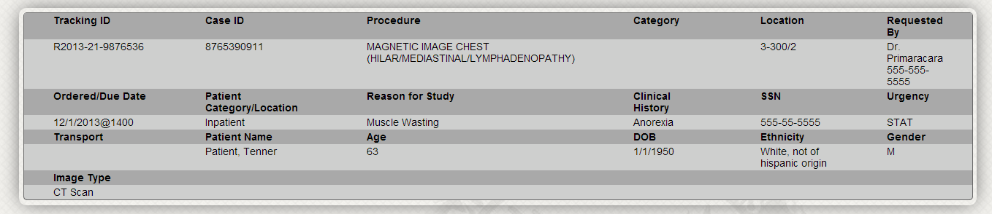

Figure - Look and feel of Dashboard Area

# Protocol Tab Content Details

## Important Message Area

This area shows important read-only messages such as detected contra-indication conditions. No acknowledgement is collected in this area; contra indication condition warnings are repeated again in the acknowledgement area.



## Static Information Area

This area displays a compact summary of the information which is also available in more detail on the other tabs of the protocol page.

NOTE: Blood coagulation panel needs to be added into the static area.

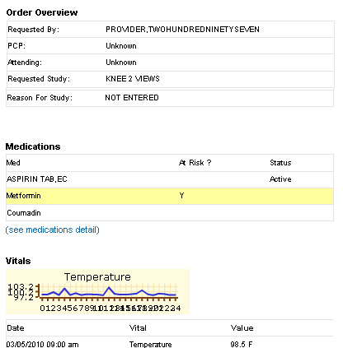

Figure - Static Information Area Sample Snippet

## Data Entry Area 1

This is the first area in which the user can enter data to a RAPTOR ticket. As illustrated in Figure 8 this area appears to the right of the ***Static Information Area***.

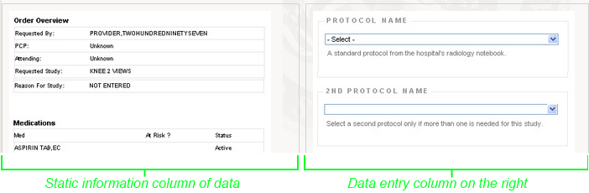

Figure - Two column layout for part of the Protocol Content area

### Sections of the Data Entry Area

With the exception of the two Protocol Name dropdowns, the data entry drop down controls are to be **combo boxes** so that users can select from list of choices but also edit/add a choice directly into the dropdown area.

#### Protocol Name

List of protocols from the protocol library. RAPTOR sorts the protocols such that those with keywords matching the study of the ticket appear above all others.

This is NOT a combo box; user can only select from the listed choices.

#### 2nd Protocol Name

List of protocols from the protocol library. RAPTOR sorts the protocols such that those with keywords matching the study of the ticket appear above all others.

This is NOT a combo box; user can only select from the listed choices.

#### Pre-medication Administration Grouping

This section contains both Hydration and Sedation sub-sections. This contains the following two Radio buttons.

1. Yes – If selected, then the subsections become active.
2. No – If selected, then the subsections become deactivated.

##### Hydration Subsection

This section has three Radio buttons.

1. None – if no hydration is elected
2. Oral – select choice from a dependent dropdown
3. IV – select the choice from a dependent dropdown

##### Sedation Subsection

This section has three Radio buttons.

1. None – if no sedation is elected
2. Oral – select choice from a dependent dropdown
3. IV – select the choice from a dependent dropdown

#### Contrast

This section has three checkboxes.

1. None – if no contrast is elected
2. Enteric – Select choice from dependent dropdown
3. IV – select choice from dependent dropdown

#### Allergy

This section has three Radio buttons.

1. Unknown – No assertion regarding allergy is being made.
2. No – Assertion that there are no known allergies
3. Yes – Assertion that there is at least one known allergy. Details would be captured elsewhere in the ticket.

#### Claustrophobic

This section has three Radio buttons.

1. Unknown – No assertion regarding claustrophobia is being made.
2. No – Assertion that the patient is not claustrophobic
3. Yes – Assertion that the patient is claustrophobic

#### Consent Required

This section has three Radio buttons.

1. Unknown – No assertion regarding consent being required is being made.
2. No – Assertion that consent is required
3. Yes – Assertion that consent is not required

## Data Entry Area 2

This is the second area in which the user can enter data to a RAPTOR ticket. This area appears under ***Static Information Area*** and ***Data Entry Area 1*** parts of the page.

### Sections of the Data Entry Area

#### Protocol Notes

The protocol notes is a free-form text entry area. There is also a configuration file driven set of buttons which when clicked automatically paste associated text directly into the notes area.

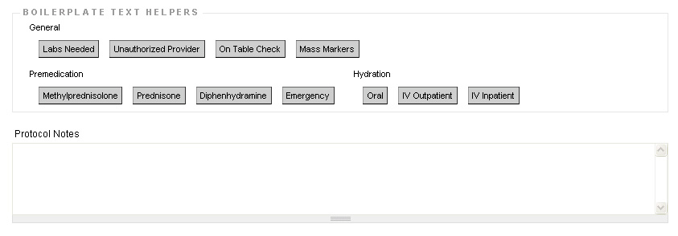

Figure - Sample protocol notes interface with text helper buttons

#### Specialist Option

The specialist option has a checkbox that then activates a dropdown of available specialists and a notes entry area. The specialist list shows all Doctors available to that RAPTOR installation. The list is sorted such that the Doctors with specialization keywords matching the study are sorted above all others.

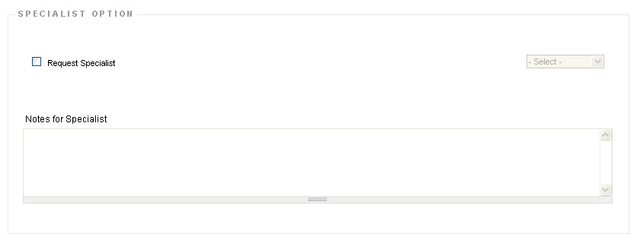

Figure - Sample UI for collaboration information capture

## Acknowledgement Area

Important messages requiring acknowledgement are displayed here and the acknowledgement is also collected here.

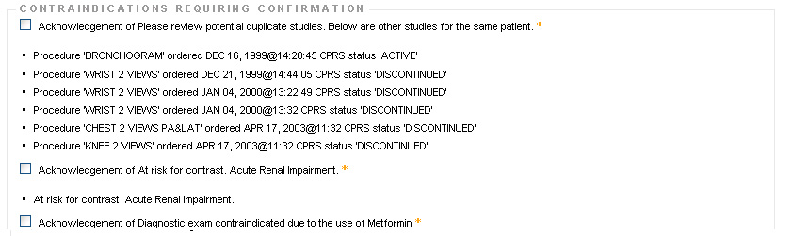

Figure - Sample acknowledgement area content

## State Changing Button Area

This is the only part of the Protocol Page where the state of a RAPTOR ticket can be changed. This is also the only place in the Protocol Page where an action can be taken to save a page. All the available buttons are described in Table 3. The displayed buttons depend on both the user role and the state of the RAPTOR ticket.

Table - Action Buttons for Active Ticket

| Button | Description |
| --- | --- |
| Approve | Saves all current entries and moves the ticket to **Approved** state. Also exits the Protocol page. (Goes back to Worklist page or continues to next ticket.) |
| Request Specialist | Saves all current entries and moves the ticket to **Collaborative** state. Also exits the Protocol page. (Goes back to Worklist page or continues to next ticket.) |
| Suspend | Saves all current entries and moves the ticket to **Inactive** state. Also exits the Protocol page. (Goes back to Worklist page or continues to next ticket.) |
| Release back to Worklist | Exits the ticket without saving any changes; instead simply takes user back to Worklist page or continues to next ticket. |
| Reserve | Automatically fills in the “Request Specialist” information as the current user and saves all current entries and moves the ticket to **Collaborative** state. Also exits the Protocol page. (Goes back to Worklist page or continues to next ticket.) |
| Send Email | Sends non-PI email to a user. The email contains a URL link to the current ticket. This button does not change the state of the ticket and does not exist the protocol page. |

# RAPTOR Data Entry Principles

The following describes the driving principles applied to the RAPTOR data collection portion of the interface.

1. The user interface does not rely exclusively on color or images to convey meaning without also including a significant character or text string to convey that meaning.
   1. Required entry fields appear with an asterisk to the right of the label
   2. Yellow background color indicates special emphasis or warning condition
   3. Red text indicates elevated concern
   4. Green background or green text indicates a value which is not of concern
2. The RAPTOR system does not generate values that affect patient care without explicit action from an authorized RAPTOR user to acknowledge or set the value.
   1. Default values will require an acknowledgement prior to saving
   2. All radio button inputs include an “Unknown” (or semantic equivalent such as “None”) option to prevent introduction of a value which is not valid.
   3. Radio buttons are used instead of checkboxes where incorrect value would have direct impact on patient care.
   4. Radio buttons are used instead of drop-downs where list of choices is small. This allows for all values to be seen by a reviewer at any time without navigating the form.
   5. Global actions that save data entry selections occur only at the bottom of the Protocol tab.
3. Minimize typing, clicking, and navigation
   1. The user interface is designed to minimize the number of clicks a user has to perform to complete a protocol workflow state.
   2. For minimization purposes more common actions are given greater weight in the UI design over less common actions.
4. Prevent data loss for accidental click
   1. Disabling a section through user input of Yes/No etc in general will disable the content but not erase any entries already made in that section. Re-enabling the section restores the values previously entered.
5. No ambiguity which patient is being processed
   1. The patient information is consistently displayed in the same part of the screen for all tabs of the protocol page.
6. No ambiguity which user made edits
   1. The logged in user is always prominently displayed at the top of all RAPTOR screens
   2. RAPTOR logs which user is logged in when changes are made
7. Touch/Tablet friendly
   1. Since touch interfaces generally do not support the hover concept, RAPTOR does not rely on hover for key information.
8. Only administrators can add/edit values for lists that are presented to users
   1. Contents for dropdowns are set by administrators
   2. If user adds/edits a value in a combo box, that new value does not automatically become part of the list for that control
9. Minimize opportunities for data loss
   1. Warn the user if they are leaving a page without saving and provide option to save or remain on page or “reserve”.
   2. Allow user to freely navigate across the various protocol page tabs without saving, no data loss should occur.

# Revision History

|  |  |  |
| --- | --- | --- |
| When | Who | What |
| 20131215 | FJF | Initial draft for iteration 1 |
| 20140201 | FJF | Updated with Worklist wireframe and numbered Protocol page wireframe. |
| 20140222 | FJF | Updated data input area information with Andrew. Also renamed Boilerplate to Dashboard in the text. Also added item 8 about combo boxes in data entry principles section. Also added item 9 about data loss prevention. |